Helpful Registration Payment Link Tips
- There are three steps to this online Registration Form: Forms, Items, Payment. You cannot move past “Forms” until you have entered the required student and caregiver information. “Items” includes the entire listing of the Mandatory Fees, Other Items (either Band or Color Guard), and Additional Booster Items. See example of these steps below. Color Guard’s landing page is very similar to this. Enter payment information on the “Payment” tab.
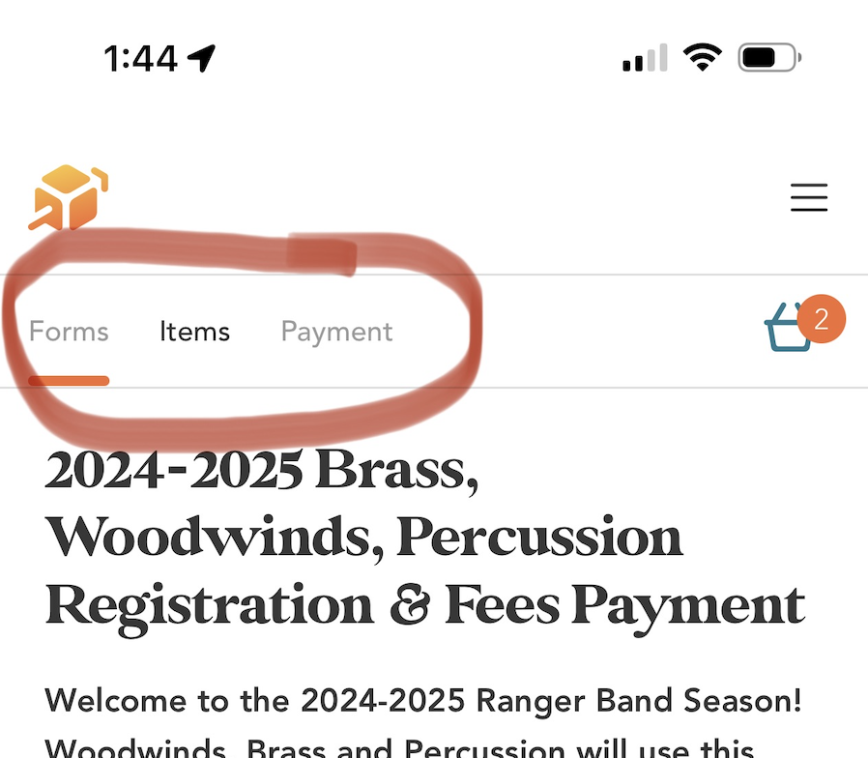
- Forms-The initial form is required to gather student and family information. It will show up in your cart, but there is no charge for this form.
- Items-Be sure to go through the entire listing of Items to purchase. This is important for all Band/Color Guard, but particularly for new members.
  - If using a mobile device, once you add an item, you’re automatically routed to Order Summary. Click outside of the Order Summary to go back to the listing of Items. Be sure to scroll down to view all Items, such as Camelbaks, Shoes, Instrument Rental, and additional Booster Items. See example below:
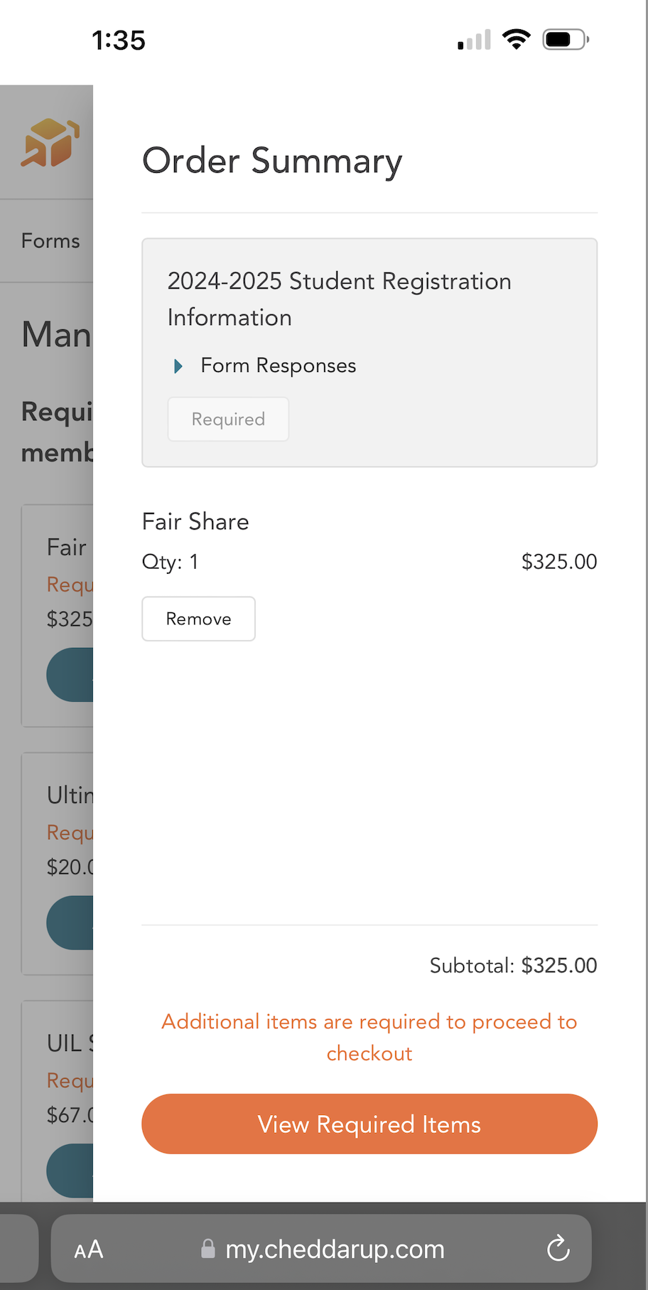
  - Because of the above, this process may be less confusing, and with fewer clicks, on a desktop.
- Payment-If you select cash/check as payment, your receipt will say “Payment Confirmation”, but you will still have to pay at registration. Anyone needing a payment plan will need to complete a payment schedule and return it to Mr. Childress.
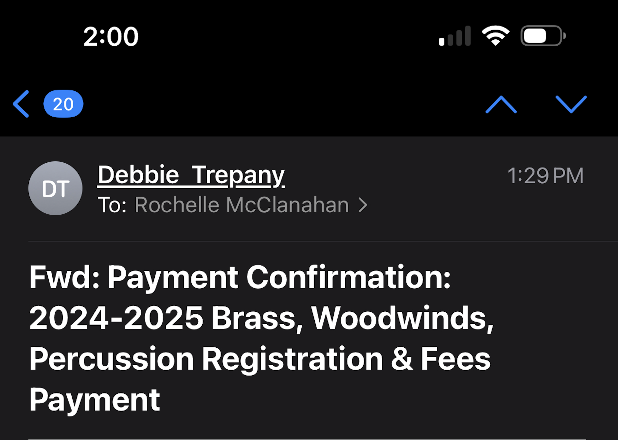

- If you purchase dinner tickets for Meet the Band and/or Stadium Dinner, you’ll receive a second email with QR codes for your tickets. Save this email to save time when you arrive. We will just scan your QR code and you’ll be on your way.
- If you prefer to wait and pay via credit card at registration, Boosters will be available to help.

